**SPINE EVALUTATION**

**On this diagram mark where your pain is:**

**spine%201116.pdf**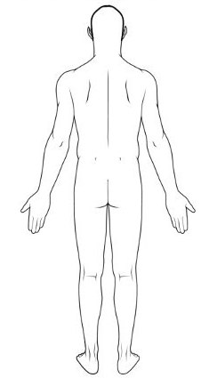

For each, circle what **BEST** applies:

* The pain is: OCCASIONAL INTERMITTENT CONSTANT WORSENING VARYING IN INTENSITY

Have you ever experienced any injury to or symptoms involving this body part in the past? **Yes / No**

Provide Details: ____________________________________________________________________________________

__________________________________________________________________________________________________

What tests have you had regarding this injury? None: _____ X-Rays: ______ MRI: _____ CT Scan: ____ EMG/NCV: _____

Have you had any treatment for this injury? None: ________ Medications: ______ Therapy: ______________

Surgery: ______ Injections: ________ Pain Management: ______

Was any of the treatment effective? ____________________________________________________________________

Did your pain come on: ____ Suddenly ____Gradually ____ Pulling ____ Lifting ____ Bending

When is your pain worse: ____Mornings ____ Evenings ____Always about the same

What makes the pain worse: ___ During Exercise ____ After Exercise ____ Sitting ____ Standing ____ Walking

___ Bending

What reduces the pain: ___ Laying down ___ Sitting ___ Standing ___ Walking ___ Movement___ Medication

___ Exercise (PT) ___ Injections ___ Brace ___ Nothing ___ Other: ________________

The above information is true to the best of my knowledge. I authorize my insurance benefits be paid directly to the physician. I understand that I am financially responsible for any balance. I also authorize Dr. Lawrence Lenderman or my insurance company to release any information required to process my claims.

_________________________________________________ _____________________________________

SIGNATURE DATE